Word Template for SISC Conference
Author Surname N.¹, Author Surname N.²*, and Author Surname N.³
¹Author affiliation - Country, ²Author Affiliation - Country, and ³Author Affiliation – Country (Use a second line if necessary)
*Corresponding Author: Email Address

Abstract
Max 200 words. This document provides formatting instructions to authors using Word in order to prepare their papers for submission. This document can be used as both an instruction set and as a template into which you can type your own text.
Keywords: max 5 words
- TEXT
This document is a Word template for paper submission to the SISC Conference. All works must be in English. You must follow these guidelines as closely as possible so that the Proceedings are in standard SISC format .
An easy way to comply with the format requirements for your paper is to use this document as a template and follow the graphic instructions. Please submit your paper in Portable Document Format (PDF). (see the corresponding instructions below about footnotes)
This section must consist of no more than 3000 words. Tables/images/figures and captions are not included in the word count. Please use 12-point Arial font for the text in this section.
This template can be used to format your paper and to style your text. All margins, line spaces, and text fonts have already been set in this template; please do not alter them. [Fig. 3] (see the corresponding instructions below about images and tables)

- ACKNOWLEDGMENTS
Insert your acknowledgments here; do not place them on the first page of your paper or as a footnote.

- REFERENCES
Number all bibliographical references in the manuscript in brackets [ ] and list them in this section in 12-point Arial font. For example:
- Brosofske K.D., Cleland D.T. & Saunders S.C. (2007), Factors influencing modern wildfire occurrence in the Mark Twain National Forest, Missouri, Southern Journal of Applied Forestry, No. 31, pp. 73-84.
- Dollinger J. M. (2003), Entrepreneurship-Strategies and Resources, Prentice Hall.]

- IMAGES AND TABLES
Graphic elements must be positioned in the center of the page and enumerated at the end of the work as follows: [Tab. 1, Tab. 2,…/Img. 1, Img. 2,.../Fig. 1, Fig. 2,…] in 10-point Arial font. Insert the figure’s references in the manuscript in brackets [ ].

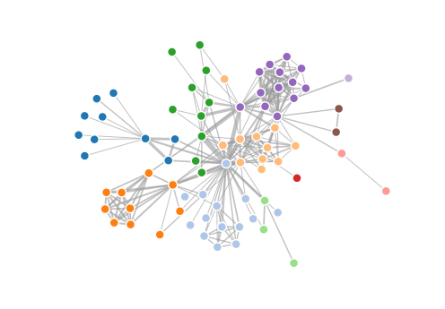
Fig. 1 Captions in 10-point Arial, justified or centered text.

Footnotes in 10-point Arial font.

